- Display the total number of employee working in the company.
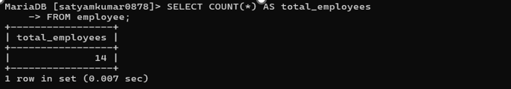
- Display the total salary being paid to all employees.
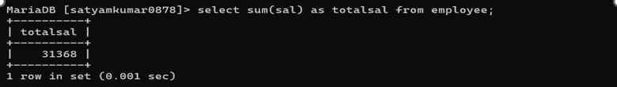
- Display the maximum salary from employee table.
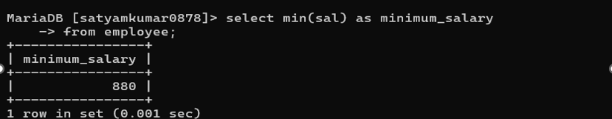

4. Display the minimum salary from employee table.
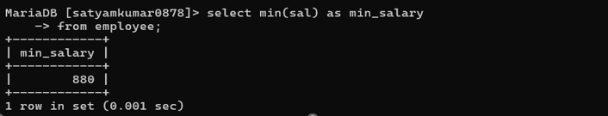
5. Display the average salary from employee table
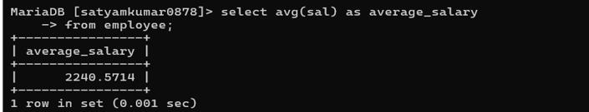
6. Display the maximum salary being paid to clerk.
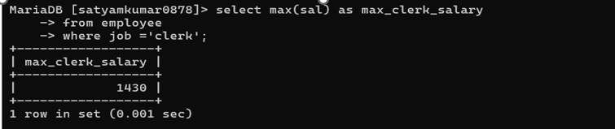
7. Display the maximum salary being paid in dept no 20.
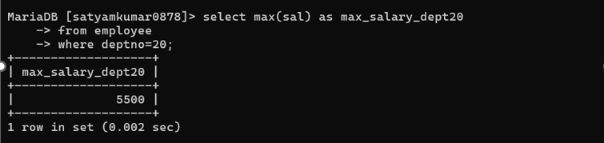
8. Display the minimum salary paid to any salesman.
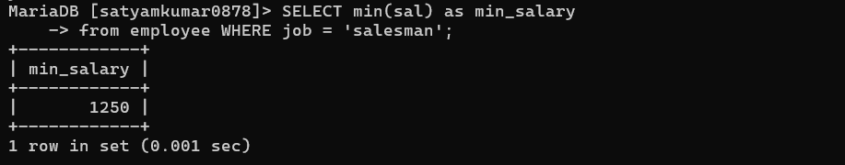

9. Display the average salary drawn by managers.
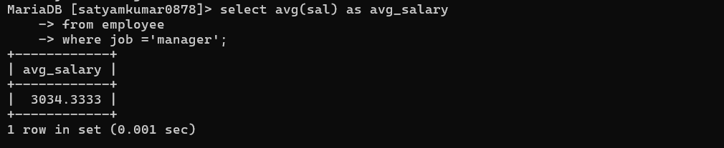

10. Display the total salary drawn by analyst working in dept no 40.
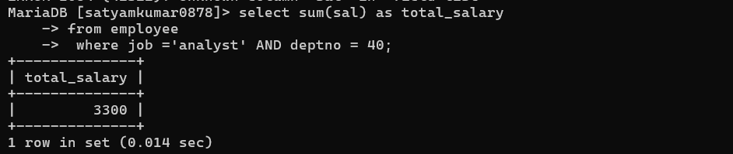
11. Display the names of the employee in Uppercase.
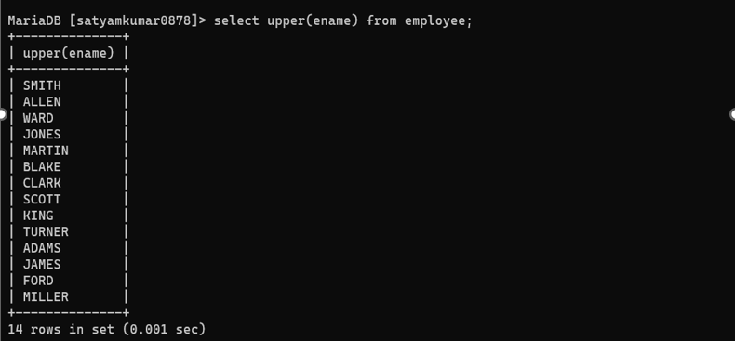
12. Display the names of the employee in Lowercase.
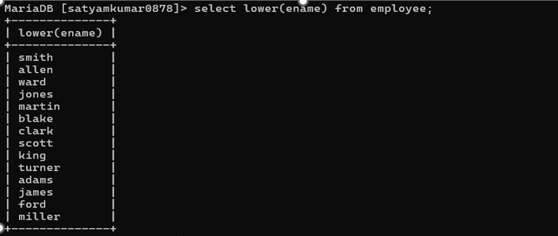

13. Display the names of the employee in Proper case.
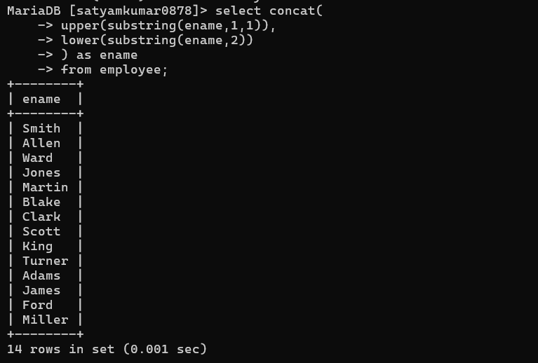

14. Display the length of Your name using appropriate function.


15. Display the length of all the employee names.
